“TAKING CARE OF MOM”
Mother’s Day- May 11, 2025

Romans 12:10 Love each other like brothers and sisters. Give each other more honor than you want for yourselves. (NCV)

Ephesians 6:2 “Honor your father and mother.” This is the first commandment with a promise: (NLT)

Exodus 21:17 “Anyone who curses their father or mother must be put to death. (NIV)

I Peter 3:7-8 7 In the same way, you husbands must give honor to your wives. Treat your wife with understanding as you live together. She may be weaker than you are, but she is your equal partner in God’s gift of new life. Treat her as you should so your prayers will not be hindered. (NLT)

Ephesians 6:2-3 2 “Honor your father and mother”—which is the first commandment with a promise— 3 “so that it may go well with you and that you may enjoy long life on the earth.” (NLT)

Ephesians 6:1 Children, obey your parents in the Lord, for this is right. (NIV)

Proverbs 3:27 Do not withhold good from those who deserve it, when it is in your power to act. (NIV)

I Timothy 5:8 If anyone does not provide for his relatives, and especially for his immediate family, he has denied the faith and is worse than an unbeliever. (NIV)

I Timothy 5:4 But if a widow has children or grandchildren, these should learn first of all to put their religion into practice by caring for their own family and so repaying their parents and grandparents, for this is pleasing to God. (NIV)

John 19:26-27 26 When Jesus saw his mother there, and the disciple whom he loved standing nearby, he said to his mother, “Dear woman, here is your son,” 27 and to the disciple, “Here is your mother.” From that time on, this disciple took her into his home. (NIV)
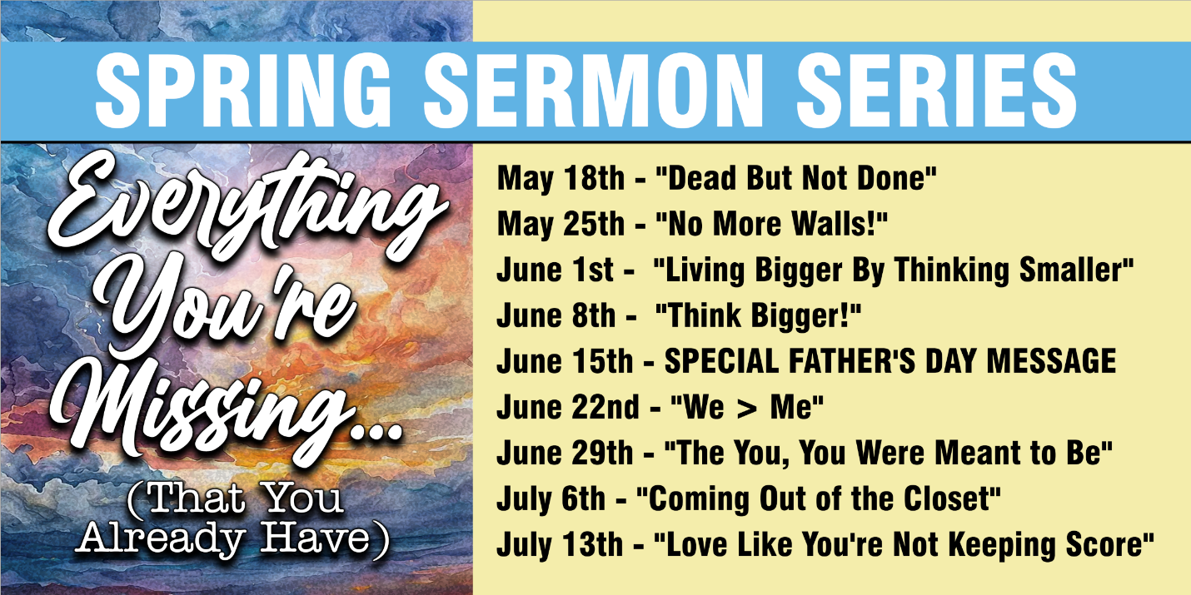

A Fresh Look at Life Through the
Book of Ephesians
Ever feel like something’s missing? Like you’re chasing peace, purpose, identity, or direction—but never quite catching it?
The book of Ephesians reminds us that we already have more than we realize.
In this series, we’ll unpack the truth about who you really are, what God’s already given you, and how to live fully and freely in the life He’s designed for you.
You’re not empty. You’re not forgotten. You’re not stuck.
You’re chosen. Empowered. Called.
Let’s discover everything you’ve been missing—that was already yours in Christ.

ADDITIONAL ANNOUNCEMENTS

YOUTH GROUP - Tuesdays 6:30-8:30 PM. They will be meeting in the dining room downstairs.

OFFERING BOXES - If you would like to leave an offering to go to the general funds for Ashland Community Church, you can drop it off in one of the offering boxes that are just to the right and left of the doors before you leave the worship center. There is also an offering box just to the left of the door if you leave the worship center from the door in the front of the worship center. Thank you for your gifts that are enabling us to increase our ministries!

BAPTISMS - We are planning to have some baptisms at the Ashland Beach in June If you are interested in being baptized, please see Ernie at the end of today’s service.

PRAYER - Toward the end of our closing song two of our deacons will come up to the left of the stage to offer prayer for anyone that would like to speak with them. They will, then hang around for a few more minutes in case anyone needs prayer.

BABY BOTTLE BLESSINGS! - We will be handing out baby bottles at the end of today’s worship service to help raise money for Haven Pregnancy Services. We’re asking people to fill the bottles with coins, paper money, or checks to be a blessing to our wonderful ministry partners in Plymouth, New Hampshire.

MUFFINS & MORE FOR MOM’S FROM DUNKIN’S - We have a choice of 3 kinds blueberry, chocolate chip and coffee cake muffins, apple fritters, coffee rolls and Boston Creme or glaze doughnuts for all the ladies in the church today. You can get your special treat from one of our KidZone kids that will be at the front of the worship center at the end of today’s worship service.

FAMILY PHOTOS - Stop by the Friendship Room either before or after this morning’s worship service to get your pictures taken by Rebekah Stout!



